**University of Asia Pacific**

**Department of Computer Science & Engineering**

**CSE 430: Compiler Design**

**Lab Problem 3: First and Follow Function**

**Introduction:**

The construction of a predictive parser is aided by two functions associated with a grammar G. These functions, **FIRST** and **FOLLOW**, allow us to fill in the entries of a predictive parsing table for G, whenever possible. First and Follow sets are needed so that the parser can properly apply the needed production rule at the correct position.

**FIRST(α)**

First(α) is a set of terminal symbols that begin in strings derived from α.

**Rule 1:**

If FIRST (α) is the set of terminals that begin the strings derived from **α**.

**Example 1:**

Consider the production rule-

A → abc | def | ghi

Then, we have-

First (A) = {a, d, g}

**Rule 2:**

If **α** 🡪 ∈, then ∈, is also in FIRST (**α**).

**Example 2:**

For a production rule X → ∈,

First(X) = {∈}

**Rule 3:**

If FIRST (α) is the set of non-terminals:

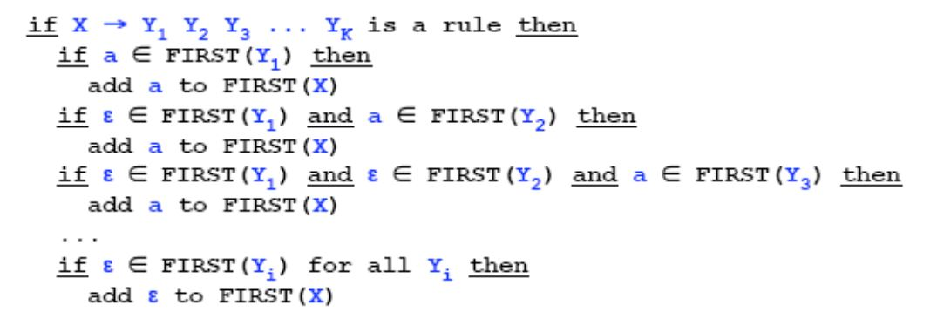

**Example 3:**

First (Y1)🡪 {a, b, ∈}

First (Y2)🡪 {c, d, ∈}

First (Y3) 🡪 {e, f, ∈}

Then First (X)🡪 {a, b, c, d, e, f, ∈}

**Example 4:**

First (Y1)🡪 {a, b, ∈}

First (Y2)🡪 {c, d, ∈}

First (Y3) 🡪 {e, f}

Then First (X)🡪 {a, b, c, d, e, f}

**Example 5:**

First (Y1)🡪 {a, b, ∈}

First (Y2)🡪 {c, d}

First (Y3) 🡪 {e, f, ∈}

Then First (X)🡪 {a, b, c, d}

**Example 6:**

First (Y1)🡪 {a, b}

First (Y2)🡪 {c, d, ∈}

First (Y3) 🡪 {e, f, ∈}

Then First (X)🡪 {a, b}

**FOLLOW (A):**

FOLLOW (A), for nonterminal A, to be the set of terminals that can appear immediately to the right of A in some sentential form. That is, the set of terminals such that there exists a derivation of the form S🡪 aAαβ for some α and β.

To compute FOLLOW (A) for all nonterminal A, apply the following rules until nothing can be added to any FOLLOW set:

**Rule 1:**

Place $ in FOLLOW(S), where S is the start symbol and $ is the input right end marker.

**Rule 2:**

If there is a production A🡪 αBβ, then everything in FIRST (β), except for ∈, is placed in FOLLOW (B).

**Rule 3:**

If there is a production A 🡪αB, or a production A 🡪 aBβ where FIRST (β) contains e (i.e., β🡪∈),

Then everything in FOLLOW (A) is in FOLLOW (B).

**Example 1:**

S 🡪 aSe | B FIRST(S) = {a, b, c, d, ε}

B 🡪 bBCf | C FIRST (B) = {b, c, d, ε}

C 🡪 cCg | d | ε FIRST(C) = {c, d, ε}

**According to Rule 1:**

FOLLOW (S) = {$}

**According to Rule 2:**

FOLLOW(C) = {f, g}

FOLLOW (B) = {c, d, f}

FOLLOW(S) = {$, e}

**According to Rule 3:**

FOLLOW (C) = {f, g} ∪ FOLLOW (B) = {c, d, e, f, g, $}

FOLLOW (B) ={c, d, f} ∪ FOLLOW(S) = {c, d, e, f, $}

FOLLOW (S) = {$, e}

**Example 2:**

Consider the expression grammar stated below:

E🡪 T E’

E’🡪 + T E’ | e

T🡪 F T’

T’🡪 * F T’ | e

F 🡪 (E) | id

Then:

FIRST (E) = FIRST (T) = FIRST (F) = {(, id}

FIRST (E’) = {+, e}

FIRST (T’) = {*, e}

FOLLOW (E) = FOLLOW (E’) = {), $}

FOLLOW (T) = FOLLOW (T’) = {+,), $}

FOLLOW (F) = {+, *,), $}

**Example 3:**

Consider the expression grammar stated below:

S → aBDh

B → cC

C → bC | ∈

D → EF

E → g | ∈

F → f | ∈

The first and follow functions are as follows-

First(S) = {a}

First (B) = {c}

First (C) = {b, ∈}

First (D) = {First (E) – ∈} ∪ First (F) = {g, f, ∈}

First (E) = {g, ∈}

First (F) = {f, ∈}

Follow (S) = {$}

Follow (B) = {First (D) – ∈} ∪ First (h) = {g, f, h}

Follow(C) = Follow (B) = {g, f, h}

Follow (D) = First (h) = {h}

Follow (E) = {First (F) – ∈} ∪ Follow (D) = {f, h}

Follow (F) = Follow (D) = {h}

**Sample Input:**

You can take input from a **text file/console.** Instead of **epsilon (**∈) use **hash (#)** symbol.

**Input:**

E -> TR

R -> +T R| #

T -> F Y

Y -> *F Y | #

F -> (E) | i

**Output:**

First (E) = {(, i,}

First(R) = {+, #,}

First (T) = {(, i,}

First(Y) = {*, #,}

First (F) = {(, i,}

-----------------------------------------------

Follow (E) = {$,),}

Follow(R) = {$,),}

Follow (T) = {+, $,),}

Follow(Y) = {+, $,),}

Follow (F) = {*, +, $,),}